KATE HAMILTON FBHS

BHS INTERMEDIATE TRAINING DAY

WEDNESDAY 1ST APRIL 2015
PLECK BARN, HIGHER ANSTY, DORSET DT2 7PU
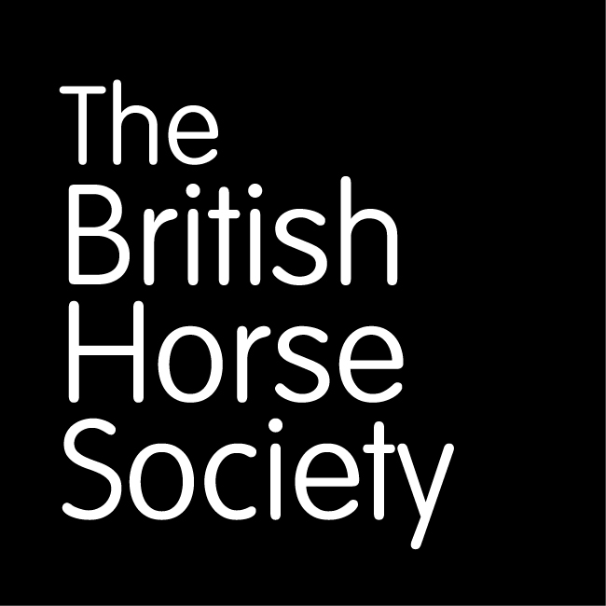 |  | CLAIRE 01258-881310 OR 07950-756289  CLAIRE@PLECKBARN.COM

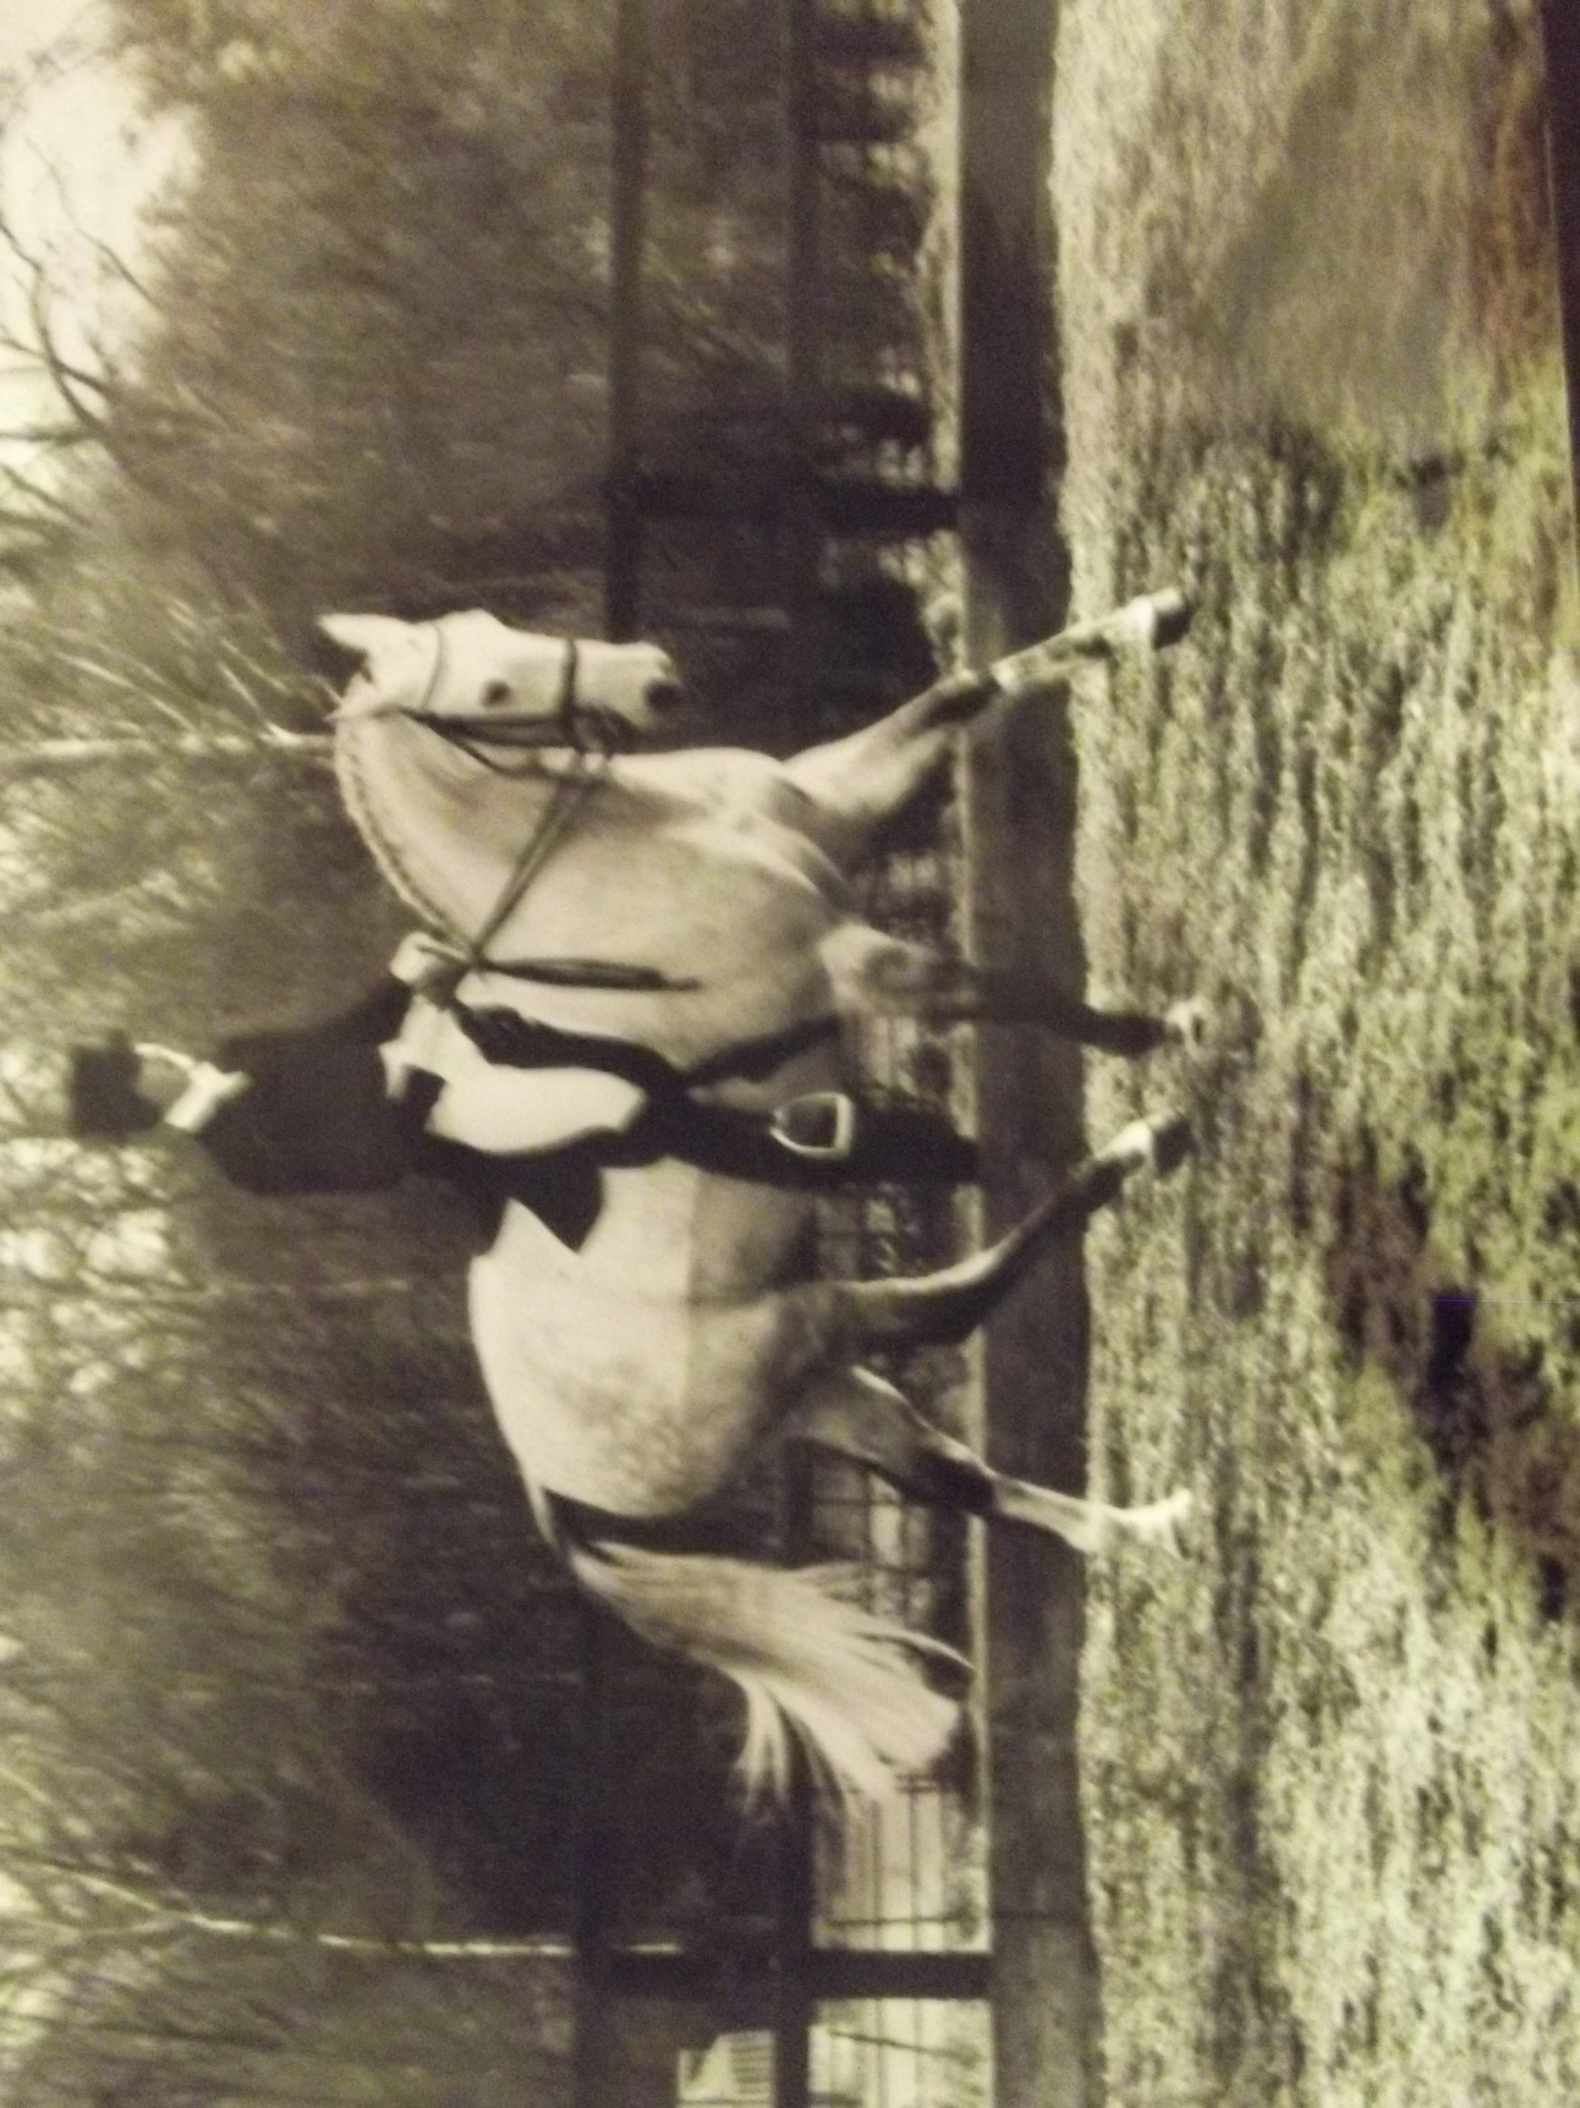  Kate Hamilton FBHS |  | Claire Hundley BHSI will assist Kate in an informal and busy day of Teaching and Discussions  Whether you already have an exam date, or simply wish to work alongside other BHSI’s and enjoy an action packed day of learning  The first of a series of training days with Claire and Kate is being offered at an introductory fee of £50.00

