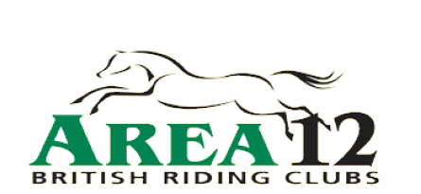
Training Date and Name | Sunday 8th February 2015  Arena Cross Country Training with Andrew Lovell
Venue: | Pontispool Equine Sports Centre
Your Name:
Your Contact Number:
Your Email Address: (Please write clearly!)
Riding Club
(ICE) Emergency Name
and contact number
for the day:
Rider Experience and goals for 2014.
90 minute session
5 riders per group
£35 for Area 12 Riding Club Members
Please indicate your jumping level (if in doubt aim lower as it’s better to be confident!)
80cm | 90cm | 1m
Please complete, sign & date this form and send with correct payment to:
Lucy Counsell, 2 Coronation Road, Bleadon, North Somerset, BS24 0PQ
Cheques payable to “Area 12 Riding Club” and please write name & contact number on back
Clinic times will be put on the Area 12 Facebook page and website.
SIGNATURE: DATE:

Andrew is well known and familiar face at various centers, horse camps and yards throughout the South West. Andrew has a broad background from Advanced level eventing, show jumping and dressage to showing ponies, hunters and working hunters. Well known as helping the nervous and/or novice combination, he can teach any level of horse and rider and is sure to be able to help you get the most from your horse.

90 minute session
5 riders per group

Area 12 Riding Club members will be priority over places and if the training is over-subscribed a waitlist will be held. Places will be filled on a first come first served basis once booking forms and cheques arrive with Lucy.

With regards to cancellations
> A full refund will be made if cancelled fourteen days prior to clinic.
> If less than 14 days notice is given refunds will be only be given if space is filled with another booking
> No refund given if cancelled 48 hours prior to clinic.

It is thanks to our Area 12 training subsidy that we are able to run this training at a subsidised cost . This is saving each rider £10.

Regards
Lucy
Area 12 Training Officer
07970 423181
lucycounsell@hotmail.com

